COMPILER DESIGN LAB

CS304

**Project Phase2: Syntax Analysis**



**M Shree Harsha Bhat**

211CS137

[mshreeharshabhat.211cs137@nitk.edu.in](mailto:mshreeharshabhat.211cs137@nitk.edu.in)

**Shreekara Rajendra**

211CS151

[shreekararajendra.211cs151@nitk.edu.in](mailto:shreekararajendra.211cs151@nitk.edu.in)

**Shyam Balaji**

211CS154

[shyambalaji.211cs154@nitk.edu.in](mailto:shyambalaji.211cs154@nitk.edu.in)

**DEPARTMENT OF COMPUTER SCIENCE AND ENGINEERING**

**NATIONAL INSTITUTE OF TECHNOLOGY KARNATAKA**

**SURATHKAL, MANGALORE – 57025**

**CODE**

**1. YACC File (.y)**

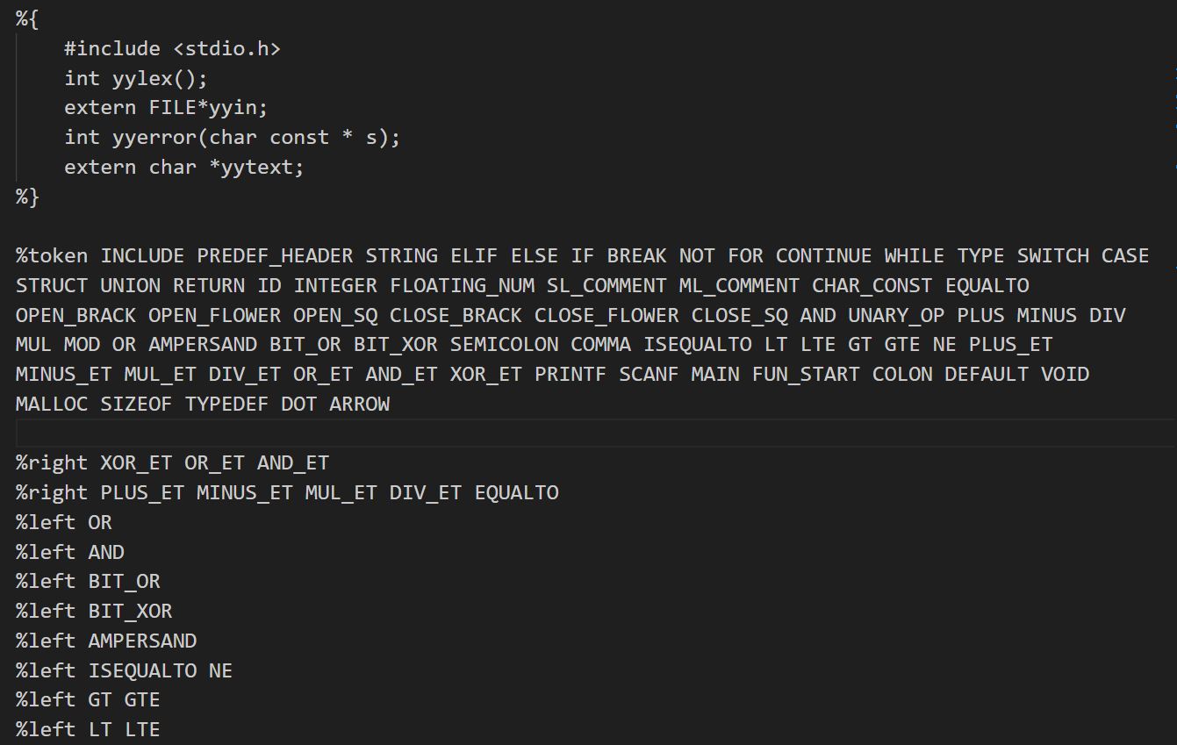

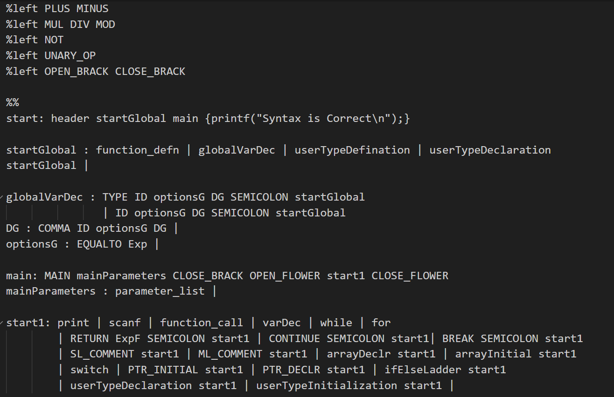

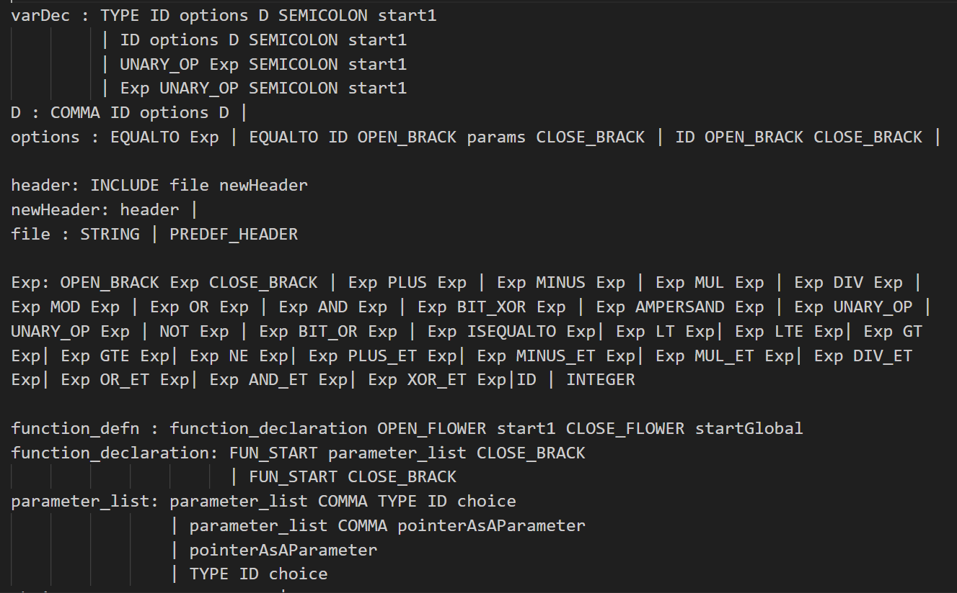

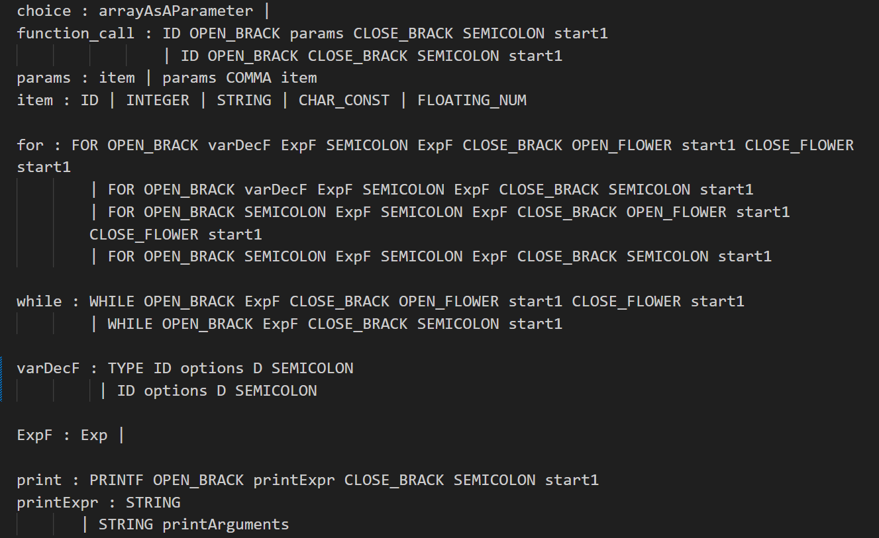

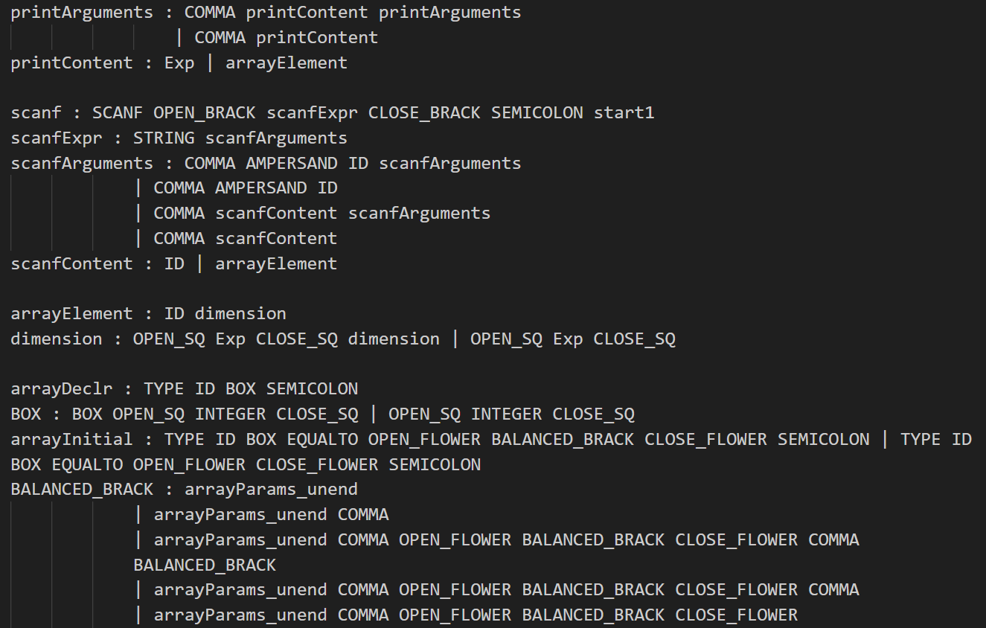

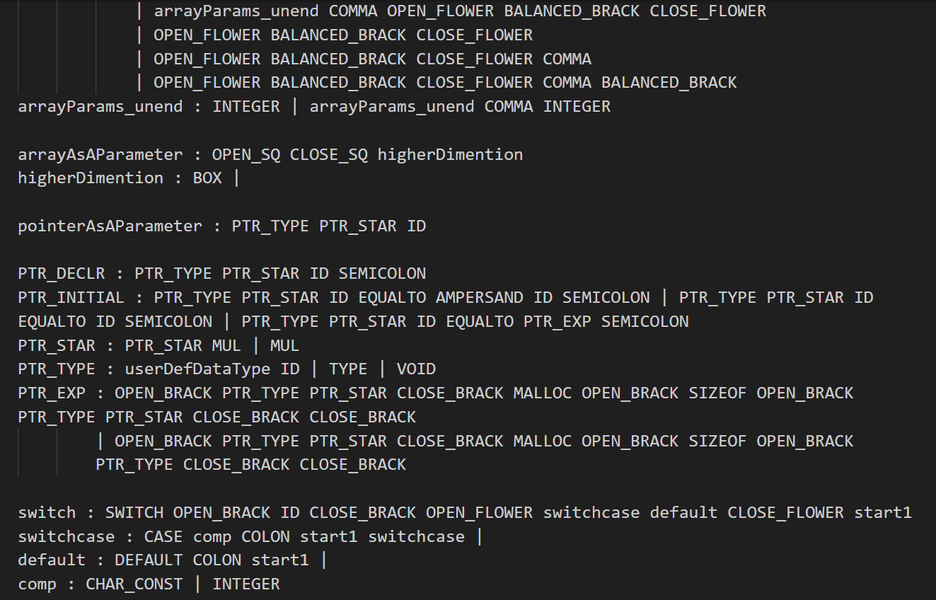

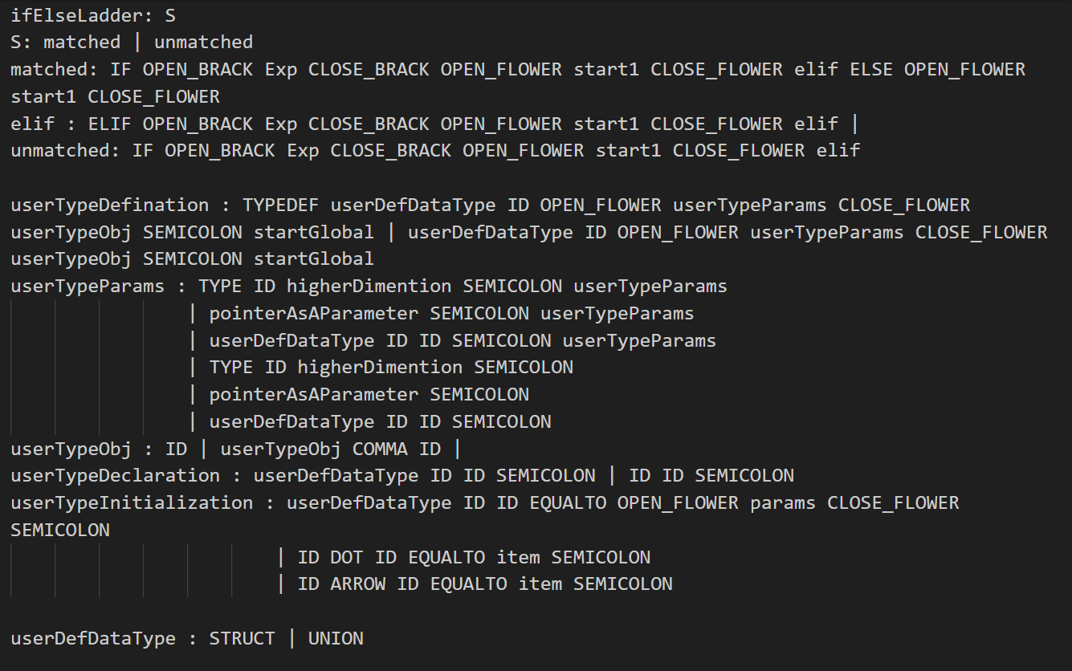

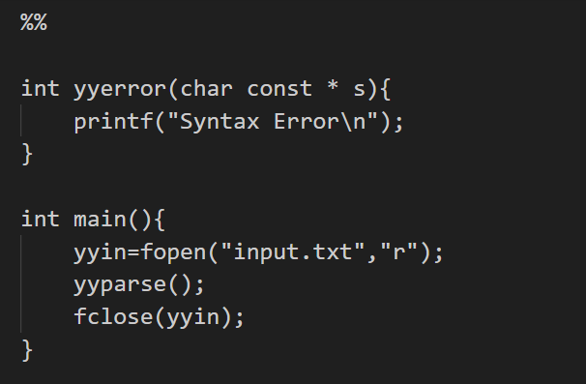

%{

#include <stdio.h>

int yylex();

extern FILE*yyin;

int yyerror(char const * s);

extern char *yytext;

%}

%token INCLUDE PREDEF_HEADER STRING ELIF ELSE IF BREAK NOT FOR CONTINUE WHILE TYPE SWITCH CASE STRUCT UNION RETURN ID INTEGER FLOATING_NUM SL_COMMENT ML_COMMENT CHAR_CONST EQUALTO OPEN_BRACK OPEN_FLOWER OPEN_SQ CLOSE_BRACK CLOSE_FLOWER CLOSE_SQ AND UNARY_OP PLUS MINUS DIV MUL MOD OR AMPERSAND BIT_OR BIT_XOR SEMICOLON COMMA ISEQUALTO LT LTE GT GTE NE PLUS_ET MINUS_ET MUL_ET DIV_ET OR_ET AND_ET XOR_ET PRINTF SCANF MAIN FUN_START COLON DEFAULT VOID MALLOC SIZEOF TYPEDEF DOT ARROW

%right XOR_ET OR_ET AND_ET

%right PLUS_ET MINUS_ET MUL_ET DIV_ET EQUALTO

%left OR

%left AND

%left BIT_OR

%left BIT_XOR

%left AMPERSAND

%left ISEQUALTO NE

%left GT GTE

%left LT LTE

%left PLUS MINUS

%left MUL DIV MOD

%left NOT

%left UNARY_OP

%left OPEN_BRACK CLOSE_BRACK

%%

start: header startGlobal main {printf("Syntax is Correct\n");}

startGlobal : function_defn | globalVarDec | userTypeDefination | userTypeDeclaration startGlobal |

globalVarDec : TYPE ID optionsG DG SEMICOLON startGlobal

| ID optionsG DG SEMICOLON startGlobal

DG : COMMA ID optionsG DG |

optionsG : EQUALTO Exp |

main: MAIN mainParameters CLOSE_BRACK OPEN_FLOWER start1 CLOSE_FLOWER

mainParameters : parameter_list |

start1: print | scanf | function_call | varDec | while | for

| RETURN ExpF SEMICOLON start1 | CONTINUE SEMICOLON start1| BREAK SEMICOLON start1

| SL_COMMENT start1 | ML_COMMENT start1 | arrayDeclr start1 | arrayInitial start1

| switch | PTR_INITIAL start1 | PTR_DECLR start1 | ifElseLadder start1

| userTypeDeclaration start1 | userTypeInitialization start1 |

varDec : TYPE ID options D SEMICOLON start1

| ID options D SEMICOLON start1

| UNARY_OP Exp SEMICOLON start1

| Exp UNARY_OP SEMICOLON start1

D : COMMA ID options D |

options : EQUALTO Exp | EQUALTO ID OPEN_BRACK params CLOSE_BRACK | ID OPEN_BRACK CLOSE_BRACK |

header: INCLUDE file newHeader

newHeader: header |

file : STRING | PREDEF_HEADER

Exp: OPEN_BRACK Exp CLOSE_BRACK | Exp PLUS Exp | Exp MINUS Exp | Exp MUL Exp | Exp DIV Exp | Exp MOD Exp | Exp OR Exp | Exp AND Exp | Exp BIT_XOR Exp | Exp AMPERSAND Exp | Exp UNARY_OP | UNARY_OP Exp | NOT Exp | Exp BIT_OR Exp | Exp ISEQUALTO Exp| Exp LT Exp| Exp LTE Exp| Exp GT Exp| Exp GTE Exp| Exp NE Exp| Exp PLUS_ET Exp| Exp MINUS_ET Exp| Exp MUL_ET Exp| Exp DIV_ET Exp| Exp OR_ET Exp| Exp AND_ET Exp| Exp XOR_ET Exp|ID | INTEGER

function_defn : function_declaration OPEN_FLOWER start1 CLOSE_FLOWER startGlobal

function_declaration: FUN_START parameter_list CLOSE_BRACK

| FUN_START CLOSE_BRACK

parameter_list: parameter_list COMMA TYPE ID choice

| parameter_list COMMA pointerAsAParameter

| pointerAsAParameter

| TYPE ID choice

choice : arrayAsAParameter |

function_call : ID OPEN_BRACK params CLOSE_BRACK SEMICOLON start1

| ID OPEN_BRACK CLOSE_BRACK SEMICOLON start1

params : item | params COMMA item

item : ID | INTEGER | STRING | CHAR_CONST | FLOATING_NUM

for : FOR OPEN_BRACK varDecF ExpF SEMICOLON ExpF CLOSE_BRACK OPEN_FLOWER start1 CLOSE_FLOWER start1

| FOR OPEN_BRACK varDecF ExpF SEMICOLON ExpF CLOSE_BRACK SEMICOLON start1

| FOR OPEN_BRACK SEMICOLON ExpF SEMICOLON ExpF CLOSE_BRACK OPEN_FLOWER start1 CLOSE_FLOWER start1

| FOR OPEN_BRACK SEMICOLON ExpF SEMICOLON ExpF CLOSE_BRACK SEMICOLON start1

while : WHILE OPEN_BRACK ExpF CLOSE_BRACK OPEN_FLOWER start1 CLOSE_FLOWER start1

| WHILE OPEN_BRACK ExpF CLOSE_BRACK SEMICOLON start1

varDecF : TYPE ID options D SEMICOLON

| ID options D SEMICOLON

ExpF : Exp |

print : PRINTF OPEN_BRACK printExpr CLOSE_BRACK SEMICOLON start1

printExpr : STRING

| STRING printArguments

printArguments : COMMA printContent printArguments

| COMMA printContent

printContent : Exp | arrayElement

scanf : SCANF OPEN_BRACK scanfExpr CLOSE_BRACK SEMICOLON start1

scanfExpr : STRING scanfArguments

scanfArguments : COMMA AMPERSAND ID scanfArguments

| COMMA AMPERSAND ID

| COMMA scanfContent scanfArguments

| COMMA scanfContent

scanfContent : ID | arrayElement

arrayElement : ID dimension

dimension : OPEN_SQ Exp CLOSE_SQ dimension | OPEN_SQ Exp CLOSE_SQ

arrayDeclr : TYPE ID BOX SEMICOLON

BOX : BOX OPEN_SQ INTEGER CLOSE_SQ | OPEN_SQ INTEGER CLOSE_SQ

arrayInitial : TYPE ID BOX EQUALTO OPEN_FLOWER BALANCED_BRACK CLOSE_FLOWER SEMICOLON | TYPE ID BOX EQUALTO OPEN_FLOWER CLOSE_FLOWER SEMICOLON

BALANCED_BRACK : arrayParams_unend

| arrayParams_unend COMMA

| arrayParams_unend COMMA OPEN_FLOWER BALANCED_BRACK CLOSE_FLOWER COMMA BALANCED_BRACK

| arrayParams_unend COMMA OPEN_FLOWER BALANCED_BRACK CLOSE_FLOWER COMMA

| arrayParams_unend COMMA OPEN_FLOWER BALANCED_BRACK CLOSE_FLOWER

| OPEN_FLOWER BALANCED_BRACK CLOSE_FLOWER

| OPEN_FLOWER BALANCED_BRACK CLOSE_FLOWER COMMA

| OPEN_FLOWER BALANCED_BRACK CLOSE_FLOWER COMMA BALANCED_BRACK

arrayParams_unend : INTEGER | arrayParams_unend COMMA INTEGER

arrayAsAParameter : OPEN_SQ CLOSE_SQ higherDimention

higherDimention : BOX |

pointerAsAParameter : PTR_TYPE PTR_STAR ID

PTR_DECLR : PTR_TYPE PTR_STAR ID SEMICOLON

PTR_INITIAL : PTR_TYPE PTR_STAR ID EQUALTO AMPERSAND ID SEMICOLON | PTR_TYPE PTR_STAR ID EQUALTO ID SEMICOLON | PTR_TYPE PTR_STAR ID EQUALTO PTR_EXP SEMICOLON

PTR_STAR : PTR_STAR MUL | MUL

PTR_TYPE : userDefDataType ID | TYPE | VOID

PTR_EXP : OPEN_BRACK PTR_TYPE PTR_STAR CLOSE_BRACK MALLOC OPEN_BRACK SIZEOF OPEN_BRACK PTR_TYPE PTR_STAR CLOSE_BRACK CLOSE_BRACK

| OPEN_BRACK PTR_TYPE PTR_STAR CLOSE_BRACK MALLOC OPEN_BRACK SIZEOF OPEN_BRACK PTR_TYPE CLOSE_BRACK CLOSE_BRACK

switch : SWITCH OPEN_BRACK ID CLOSE_BRACK OPEN_FLOWER switchcase default CLOSE_FLOWER start1

switchcase : CASE comp COLON start1 switchcase |

default : DEFAULT COLON start1 |

comp : CHAR_CONST | INTEGER

ifElseLadder: S

S: matched | unmatched

matched: IF OPEN_BRACK Exp CLOSE_BRACK OPEN_FLOWER start1 CLOSE_FLOWER elif ELSE OPEN_FLOWER start1 CLOSE_FLOWER

elif : ELIF OPEN_BRACK Exp CLOSE_BRACK OPEN_FLOWER start1 CLOSE_FLOWER elif |

unmatched: IF OPEN_BRACK Exp CLOSE_BRACK OPEN_FLOWER start1 CLOSE_FLOWER elif

userTypeDefination : TYPEDEF userDefDataType ID OPEN_FLOWER userTypeParams CLOSE_FLOWER userTypeObj SEMICOLON startGlobal | userDefDataType ID OPEN_FLOWER userTypeParams CLOSE_FLOWER userTypeObj SEMICOLON startGlobal

userTypeParams : TYPE ID higherDimention SEMICOLON userTypeParams

| pointerAsAParameter SEMICOLON userTypeParams

| userDefDataType ID ID SEMICOLON userTypeParams

| TYPE ID higherDimention SEMICOLON

| pointerAsAParameter SEMICOLON

| userDefDataType ID ID SEMICOLON

userTypeObj : ID | userTypeObj COMMA ID |

userTypeDeclaration : userDefDataType ID ID SEMICOLON | ID ID SEMICOLON

userTypeInitialization : userDefDataType ID ID EQUALTO OPEN_FLOWER params CLOSE_FLOWER SEMICOLON

| ID DOT ID EQUALTO item SEMICOLON

| ID ARROW ID EQUALTO item SEMICOLON

userDefDataType : STRUCT | UNION

%%

int yyerror(char const * s){

printf("Syntax Error\n");

}

int main(){

yyin=fopen("input.txt","r");

yyparse();

fclose(yyin);

}

**LEX File (.l)**

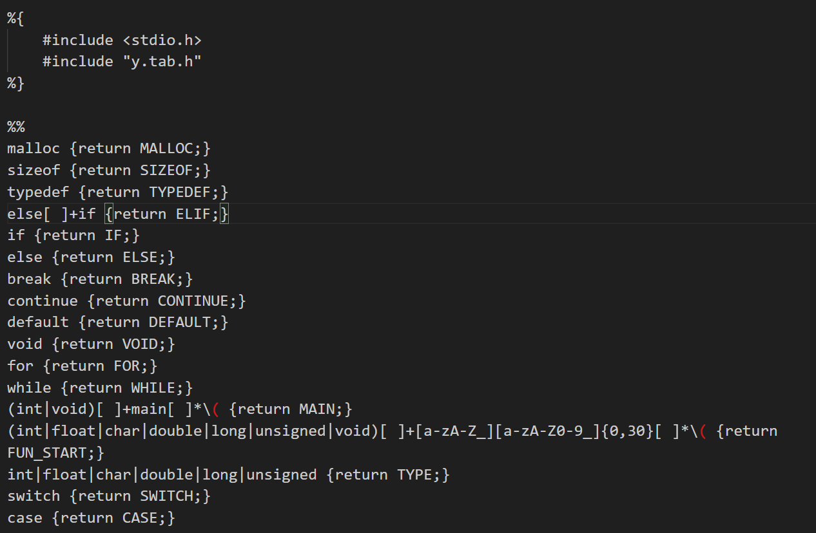

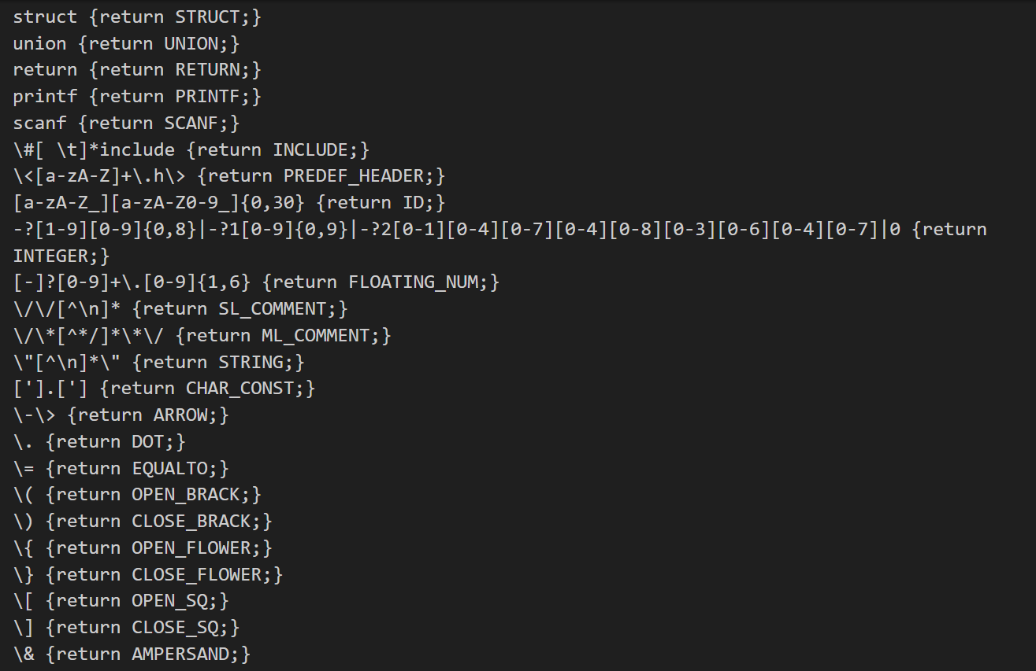

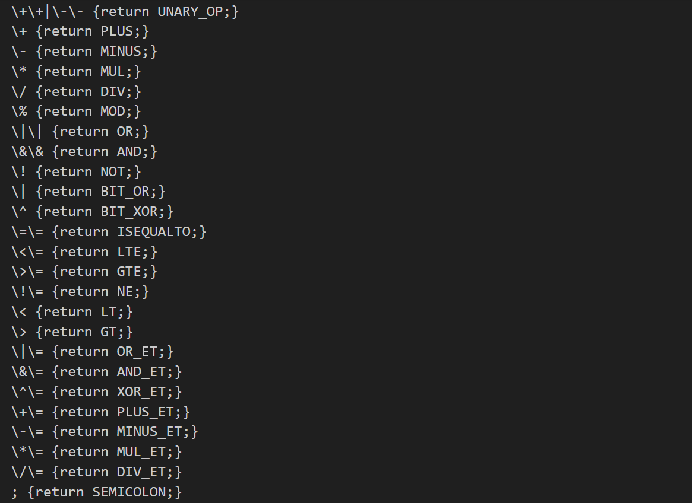

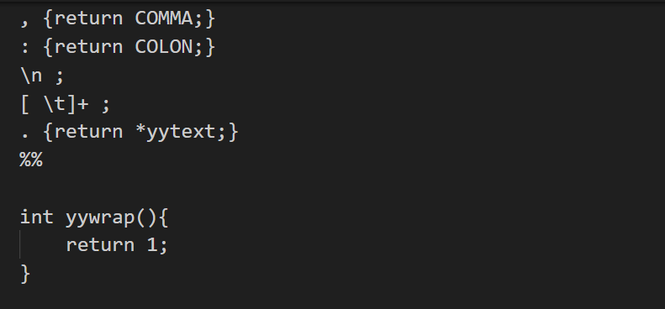

%{

#include <stdio.h>

#include "y.tab.h"

%}

%%

malloc {return MALLOC;}

sizeof {return SIZEOF;}

typedef {return TYPEDEF;}

else[ ]+if {return ELIF;}

if {return IF;}

else {return ELSE;}

break {return BREAK;}

continue {return CONTINUE;}

default {return DEFAULT;}

void {return VOID;}

for {return FOR;}

while {return WHILE;}

(int|void)[ ]+main[ ]*\( {return MAIN;}

(int|float|char|double|long|unsigned|void)[ ]+[a-zA-Z_][a-zA-Z0-9_]{0,30}[ ]*\( {return FUN_START;}

int|float|char|double|long|unsigned {return TYPE;}

switch {return SWITCH;}

case {return CASE;}

struct {return STRUCT;}

union {return UNION;}

return {return RETURN;}

printf {return PRINTF;}

scanf {return SCANF;}

\#[ \t]*include {return INCLUDE;}

\<[a-zA-Z]+\.h\> {return PREDEF_HEADER;}

[a-zA-Z_][a-zA-Z0-9_]{0,30} {return ID;}

-?[1-9][0-9]{0,8}|-?1[0-9]{0,9}|-?2[0-1][0-4][0-7][0-4][0-8][0-3][0-6][0-4][0-7]|0 {return INTEGER;}

[-]?[0-9]+\.[0-9]{1,6} {return FLOATING_NUM;}

\/\/[^\n]* {return SL_COMMENT;}

\/\*[^*/]*\*\/ {return ML_COMMENT;}

\"[^\n]*\" {return STRING;}

['].['] {return CHAR_CONST;}

\-\> {return ARROW;}

\. {return DOT;}

\= {return EQUALTO;}

\( {return OPEN_BRACK;}

\) {return CLOSE_BRACK;}

\{ {return OPEN_FLOWER;}

\} {return CLOSE_FLOWER;}

\[ {return OPEN_SQ;}

\] {return CLOSE_SQ;}

\& {return AMPERSAND;}

\+\+|\-\- {return UNARY_OP;}

\+ {return PLUS;}

\- {return MINUS;}

\* {return MUL;}

\/ {return DIV;}

\% {return MOD;}

\|\| {return OR;}

\&\& {return AND;}

\! {return NOT;}

\| {return BIT_OR;}

\^ {return BIT_XOR;}

\=\= {return ISEQUALTO;}

\<\= {return LTE;}

\>\= {return GTE;}

\!\= {return NE;}

\< {return LT;}

\> {return GT;}

\|\= {return OR_ET;}

\&\= {return AND_ET;}

\^\= {return XOR_ET;}

\+\= {return PLUS_ET;}

\-\= {return MINUS_ET;}

\*\= {return MUL_ET;}

\/\= {return DIV_ET;}

; {return SEMICOLON;}

, {return COMMA;}

: {return COLON;}

\n ;

[ \t]+ ;

. {return *yytext;}

%%

int yywrap(){

return 1;

}

**Various Structures of C Programming Language Implemented for Syntax Checking**

1. Syntax for Header File

2. Main Function

3. Function Definition + Declaration

4. Function call

5. Printf and Scanf

6. Variable Declaration

7. Array Declaration

8. if else ladder

9. for loop

10. while loop

11. Expressions

12. Comments

13. Switch case

14. Pointer

15. Structures and Unions

**INPUT TEST CASES**

Test Case 1: ALL CORRECT

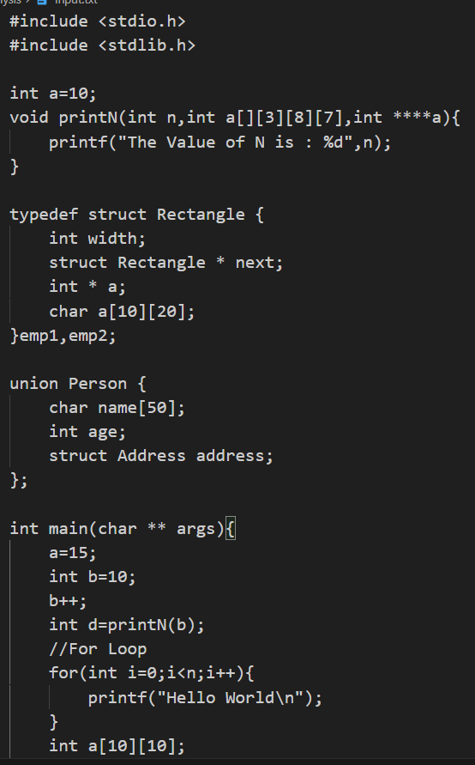 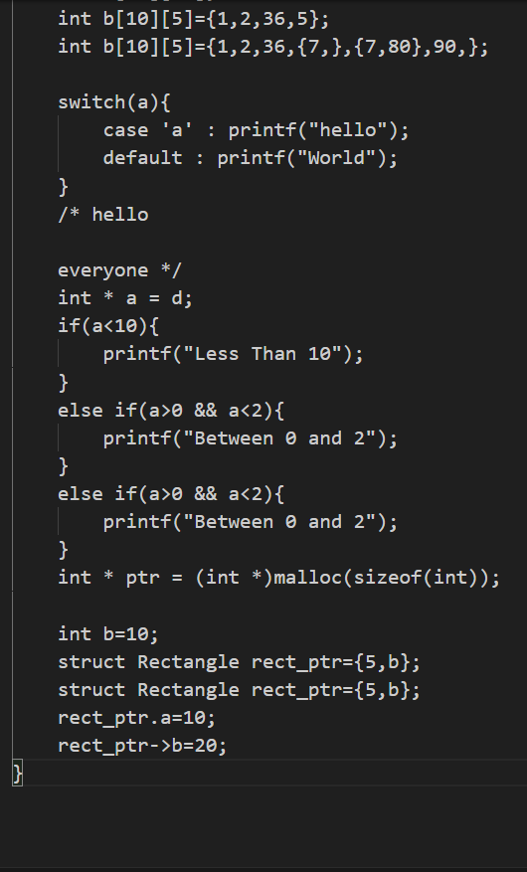

**OUTPUT**

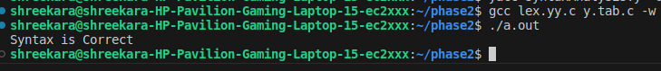

TEST CASE 2: ERROR IN Header File Syntax

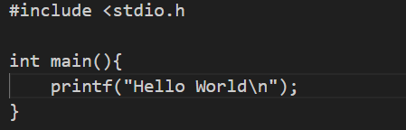

**OUTPUT**

TEST CASE 3: ERROR IN Function Definition Syntax

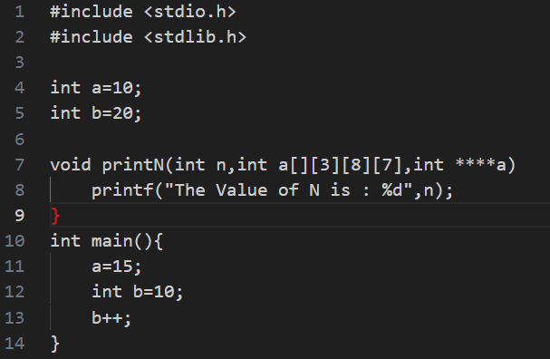

**OUTPUT**

TEST CASE 4: ERROR IN Struct Syntax

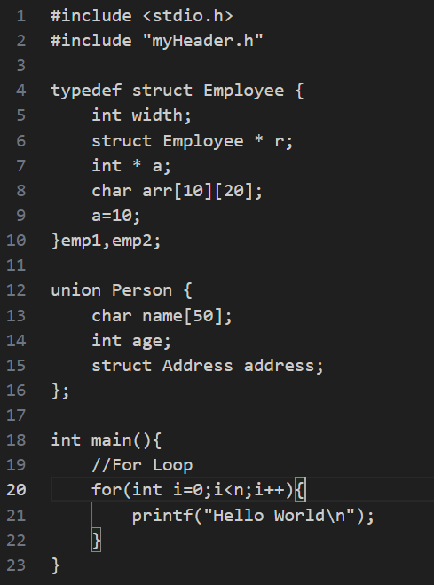

**OUTPUT**

TEST CASE 5: ERROR IN Expression Syntax

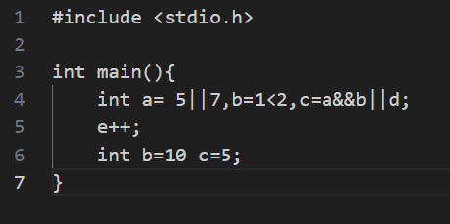

**OUTPUT**

TEST CASE 6: ERROR IN FOR Loop Syntax

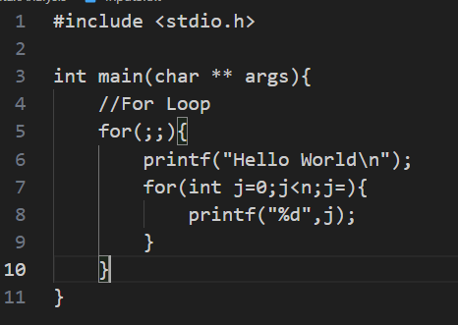

**OUTPUT**

TEST CASE 7: ERROR IN Variable Declaration Syntax

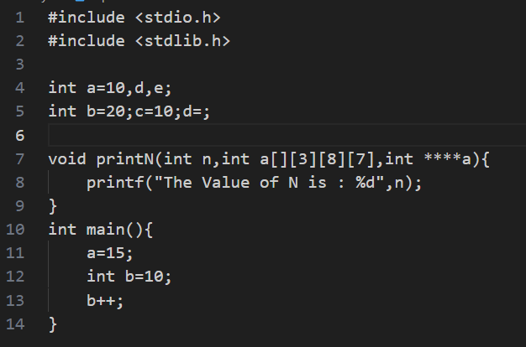

**OUTPUT**

TEST CASE 8: ERROR IN Array Declaration Syntax

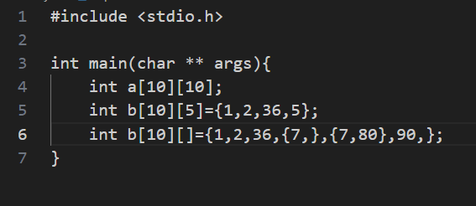

**OUTPUT**

TEST CASE 9: ERROR IN Switch Case Syntax

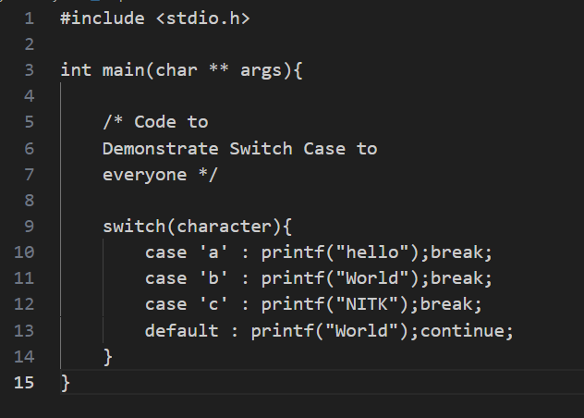

**OUTPUT**

TEST CASE 10: ERROR IN While Loop Syntax

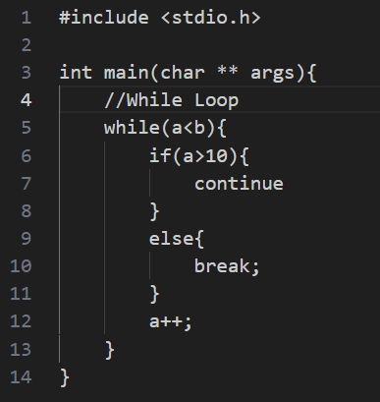

**OUTPUT**

TEST CASE 11: ERROR IN If Else Ladder Syntax

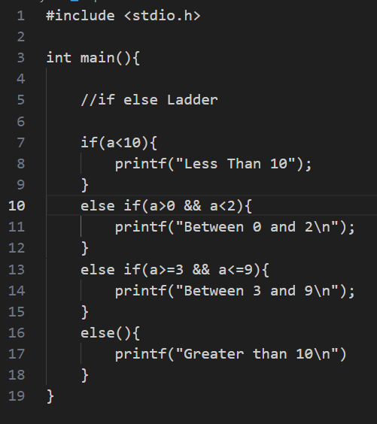

**OUTPUT**

TEST CASE 12: ERROR IN Pointer Declaration Syntax

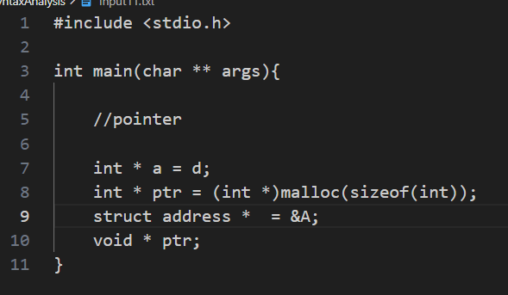

**OUTPUT**

TEST CASE 13: ERROR IN Structure and Union Initialization and Declaration Syntax

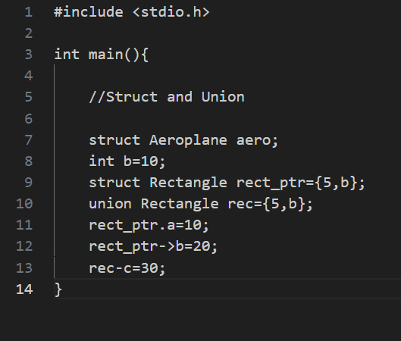

**OUTPUT**

TEST CASE 14: ERROR IN function call statements Syntax

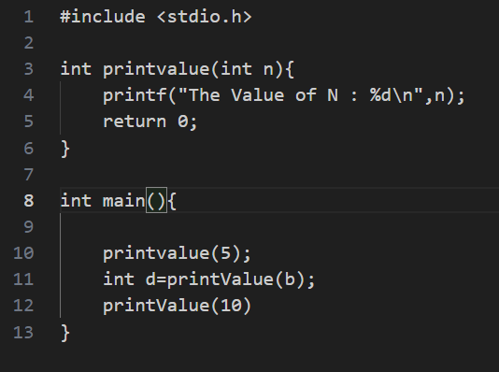

**OUTPUT**

TEST CASE 15: ERROR IN Printf and Scanf Statements Syntax

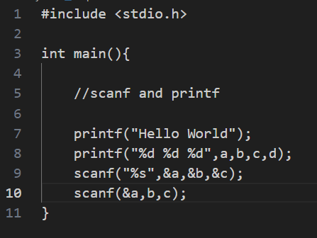

**OUTPUT**